EXP.NO: 7
Write a Servlet program to store a user's preferences (like theme or language) using cookies.
AIM:
To develop a Java Servlet-based MiniTimes India Online News Portal that stores user preferences such as theme, language, and news category using cookies and retrieves these preferences on subsequent visits to personalize the content.
ALGORITHM:
Step 1: Start the program
Step 2: Display the MiniTimes India preference selection page
Step 3: User selects theme, language, and category
Step 4: Submit the form to servlet using POST method
Step 5: Retrieve selected values using request.getParameter()
Step 6: Create cookies for theme, language, and category
Step 7: Set cookie expiry time using setMaxAge()
Step 8: Add cookies to response using response.addCookie()
Step 9: Redirect to servlet using response.sendRedirect()
Step 10: On subsequent request, retrieve cookies using request.getCookies()
Step 11: Read cookie values and store in variables
Step 12: Apply selected theme and display preferred news category
Step 13: Show personalized MiniTimes India news portal page
Step 14: Stop the program

.
CODE:
Index.html:
<!DOCTYPE html>
<html>
<head>
<title>MiniTimes India</title>
<style>
body{
font-family:Arial;
background:#f4f4f4;
margin:0;
}
.header{
background:#d32f2f;
color:white;
padding:15px;
text-align:center;
}
.container{
width:50%;
margin:40px auto;
background:white;
padding:20px;
box-shadow:0px 0px 10px gray;
border-radius:8px;
}
select,button{
width:100%;
padding:10px;
margin-top:10px;
}
button{
background:#d32f2f;
color:white;
border:none;
}
</style>
</head>
<body>

<div class="header">
<h1>MiniTimes India</h1>
</div>

<div class="container">
<h2>Select Your Preferences</h2>

<form action="MiniTimesServlet" method="post">

<label>Theme</label>
<select name="theme">
<option value="Light">Light</option>
<option value="Dark">Dark</option>
</select>

<label>Language</label>
<select name="language">
<option value="English">English</option>
<option value="Tamil">Tamil</option>
<option value="Hindi">Hindi</option>
</select>

<label>Category</label>
<select name="category">
<option value="Politics">Politics</option>
<option value="Sports">Sports</option>
<option value="Technology">Technology</option>
<option value="Cinema">Cinema</option>
</select>

<br><br>
<button type="submit">Save Preferences</button>

</form>
</div>

</body>
</html>
web.XML:
<web-app xmlns="https://jakarta.ee/xml/ns/jakartaee"
xmlns:xsi="http://www.w3.org/2001/XMLSchema-instance"
xsi:schemaLocation="https://jakarta.ee/xml/ns/jakartaee
https://jakarta.ee/xml/ns/jakartaee/web-app_5_0.xsd"
version="5.0">

<servlet>
<servlet-name>MiniTimesServlet</servlet-name>
<servlet-class>com.example.MiniTimesServlet</servlet-class>
</servlet>

<servlet-mapping>
<servlet-name>MiniTimesServlet</servlet-name>
<url-pattern>/MiniTimesServlet</url-pattern>
</servlet-mapping>

</web-app>
Servelet.java
package com.example;
import java.io.IOException;
import java.io.PrintWriter;
import jakarta.servlet.ServletException;
import jakarta.servlet.http.Cookie;
import jakarta.servlet.http.HttpServlet;
import jakarta.servlet.http.HttpServletRequest;
import jakarta.servlet.http.HttpServletResponse;
public class MiniTimesServlet extends HttpServlet {
private static final long serialVersionUID = 1L;
protected void doPost(HttpServletRequest request, HttpServletResponse response)
throws ServletException, IOException {
String theme=request.getParameter("theme");
String language=request.getParameter("language");
String category=request.getParameter("category");
Cookie c1=new Cookie("theme",theme);
Cookie c2=new Cookie("language",language);
Cookie c3=new Cookie("category",category);
c1.setMaxAge(24*60*60);
c2.setMaxAge(24*60*60);
c3.setMaxAge(24*60*60);

response.addCookie(c1);
response.addCookie(c2);
response.addCookie(c3);
response.sendRedirect("MiniTimesServlet");
}

protected void doGet(HttpServletRequest request,HttpServletResponse response)
throws ServletException,IOException{
response.setContentType("text/html");
PrintWriter out=response.getWriter();
String theme="Light";
String language="English";
String category="Politics";
Cookie cookies[]=request.getCookies();
if(cookies!=null){
for(Cookie c:cookies){
if(c.getName().equals("theme")) theme=c.getValue();
if(c.getName().equals("language")) language=c.getValue();
if(c.getName().equals("category")) category=c.getValue();
}
}
out.println("<html><head><title>MiniTimes India</title>");
if(theme.equals("Dark")){
out.println("<style>");
out.println("body{background:#121212;color:white;font-family:Arial;margin:0}");
out.println(".header{background:black;padding:15px;text-align:center}");
out.println(".nav{background:#333;padding:10px;text-align:center}");
out.println(".card{background:#1e1e1e;padding:15px;margin:10px;border-radius:8px}");
out.println("</style>");
}else{
out.println("<style>");
out.println("body{background:#f4f4f4;font-family:Arial;margin:0}");
out.println(".header{background:#d32f2f;color:white;padding:15px;text-align:center}");
out.println(".nav{background:#eee;padding:10px;text-align:center}");
out.println(".card{background:white;padding:15px;margin:10px;box-shadow:0 0 5px gray}");
out.println("</style>");
}
out.println("</head><body>");
out.println("<div class='header'><h1>📰 MiniTimes India</h1></div>");
out.println("<div class='nav'>Home | Politics | Sports | Technology | Cinema</div>");
out.println("<h2>Language: "+language+"</h2>");
out.println("<h3>Top News - "+category+"</h3>");
out.println("<div class='card'>Breaking News 1</div>");
out.println("<div class='card'>Breaking News 2</div>");
out.println("<br><a href='index.html'>Change Preferences</a>");
out.println("</body></html>");
}
}

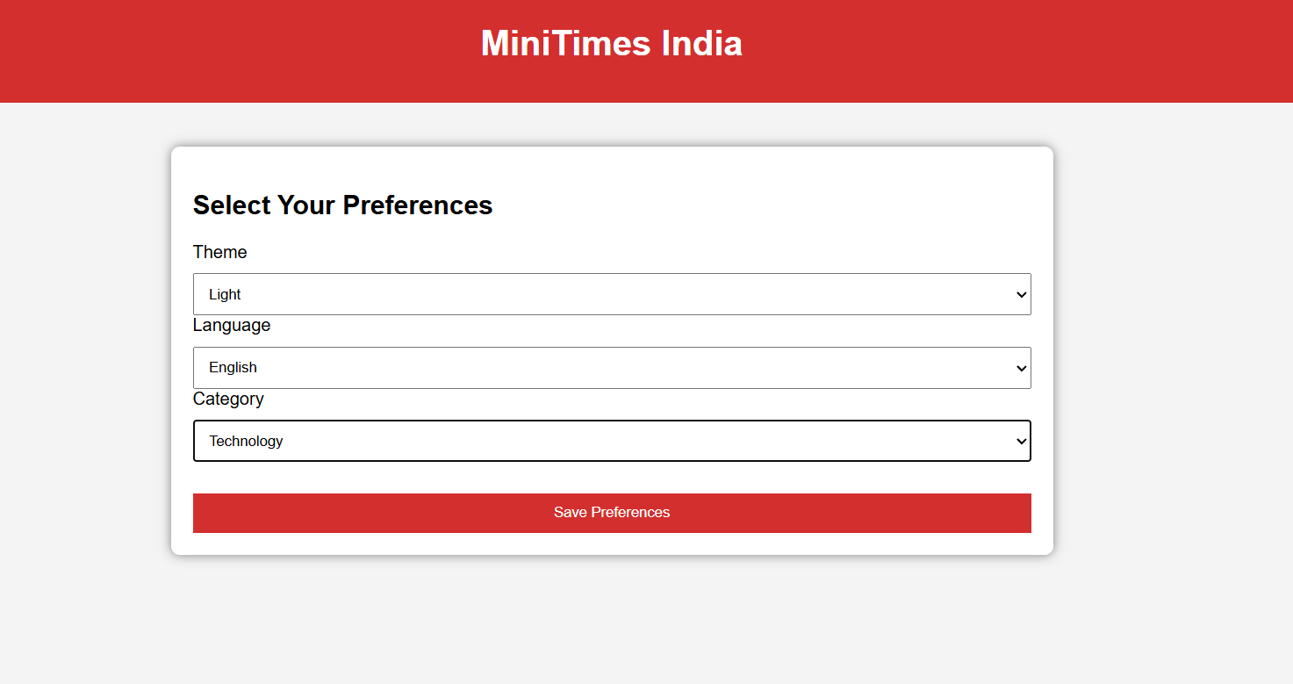
OUTPUT:

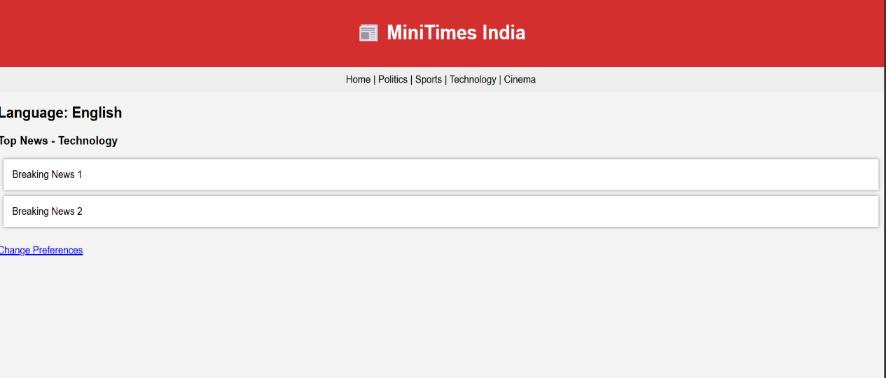
Result:
Html Page is created with embedded Bangalore map along with hot spot, frames ,map & Links.

